Rotary Leadership Institute
Certificate

This is to certify that

Robert Alan Harris

Has completed Part One of the Rotary Leadership Institute

Presented on 1/15/2022

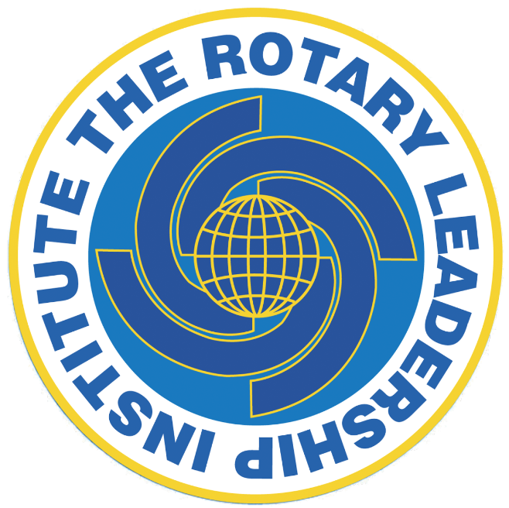 | Tom Green  Tom Green, RLI Director, 2021-22  Bo Porter  \Bo Porter , District Chair, 2021-22 | 

